Strain Gauge Sensor

Objective within Prototype
A device is needed to accurately measure the strumming component of guitar playing. The implementation of the chosen design should be able to detect specifically which string is being strummed.

Ideas / Possibilities
Push Button
A push button is a device that can complete an electrical circuit when pressed. It consists of a spring that when pressed, connects wires, allowing current to flow [1].
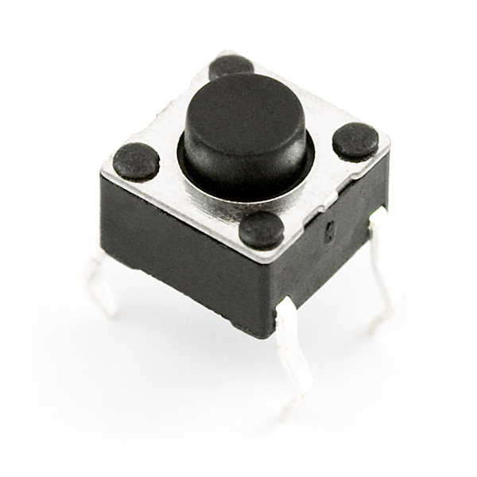
Figure 1: Push Button [2]

Some applications of push buttons [3] :
- Lights
- Calculators
- Telephones
- Kitchen appliances

Motion Sensor
Motion sensors are electronic devices that detect movement through disruptions in sound or radiation [4].

Some applications of motions sensors [4]:
- Security systems
- Phones
- Automatic soap dispensers
- Game consoles

Types of motion sensors [4] [5]:
- Active (Figure 2): “have both a transmitter and a receiver”; detects sound or radiation disruptions to the sensor’s range
- Passive (Figure 3): have a receiver that detects changes in radiation

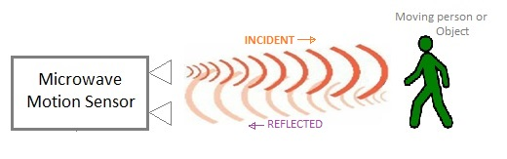
Figure 2: Active Motion Sensor [5]

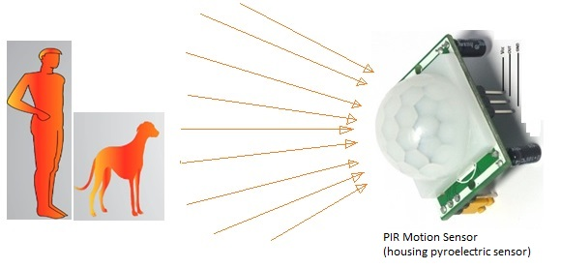
Figure 3: Passive Motion Sensor [5]

Strain Gauge Sensor
Strain gauge sensors (Figure 4) detect and measure changes in force. They contain springs that are sensitive to tensile and compressive forces [6] (Figure 5), and turn the readings into measurable electrical resistances. The value of the resistances indicates the amount of stress and strain within certain objects due to external forces [7].

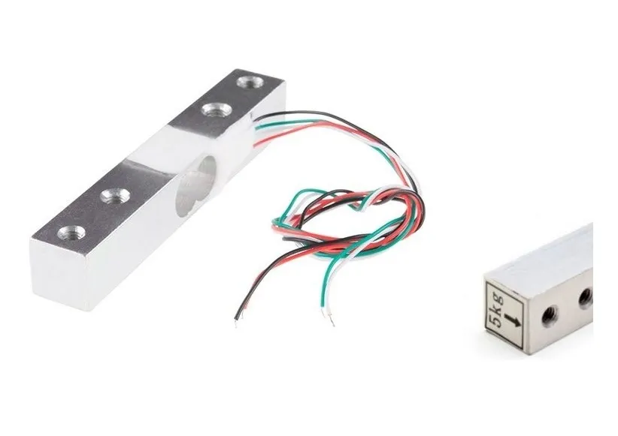  Figure 4: Strain Gauge Sensor [8] | 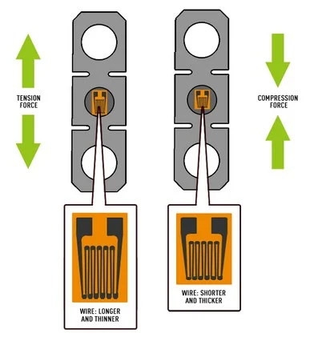  Figure 5: Strain Gauge Sensor Functionality Under Tension  and Compression [9]

Some applications of strain gauge sensors [10]:
- Ensuring structural safety (bridges, buildings, tunnels, etc.)
- “Early warning of landslides”
- Engineering calculations

Comparison Between Ideas
Table 1: Comparison Matrix for Ideas
Selection Criteria (for Arduino element) | Push Button | Motion Sensor | Strain Gauge Sensor
Minimum Strumming Force Required | ~ 1 lbs [11] | Depends on implementation | 0.11 lbs (50 g) [12]
Ability to Detect Varying Dynamics (Range of Forces) | No | No | Yes  0.11 lbs to 10000 lbs (0.050 - 4536 kg) [12]  Up to 5kg [13]  Up to 450 N [14]
Cost | 4 / $1.00 [15] | $24.95 [16] | Depends on seller [17]  $11.95 [18]  $13.95 [14]

From the Comparison Matrix in Table 1, strain gauge sensors are the optimal choice in minimum strumming force required and ability to detect varying dynamics. This leads to a detailed design selection of strain gauge sensors to accurately measure the strumming component of guitar playing.

Implementation within Prototype
The implementation of strain gauge sensors will be through usage of Arduinos, electric circuit elements, guitar strings, and a securing mechanism.

Arduinos and Electric Circuit Elements
Malek’s Guitar utilizes an Arduino and electric circuit elements in the fretting component. Utilizing the same computer system allows for more compatibility between the fretting and strumming components. The data from both components will be sent to the Arduino, allowing for the program to analyze and auditorily generate the correct notes more efficiently. Additionally, the Arduino acts like a power source for the circuit and hence, the strain gauge sensors. Electric circuit elements are necessary to link (with wired connections) the strain gauge sensor with the Arduino (Figure 6).

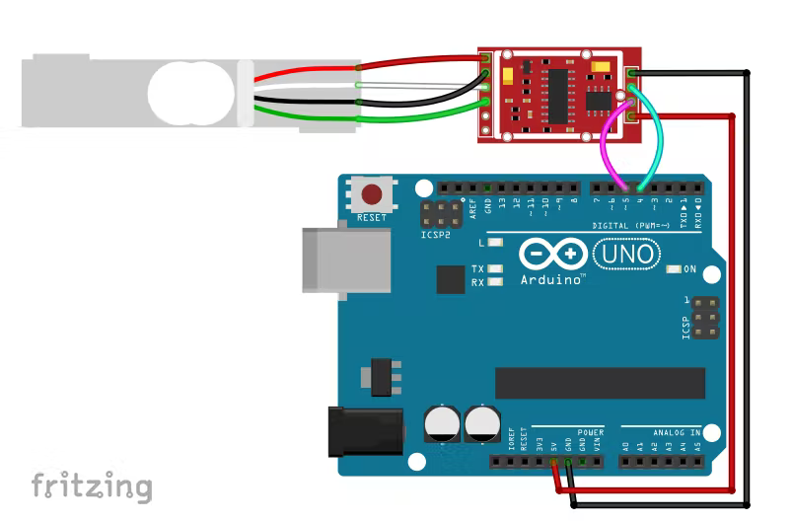
Figure 6: Strain Gauge Sensor (top) and Arduino (bottom right) Circuit [source]

Guitar Strings
The strain gauge sensor measures the forces each guitar string is being strummed with. They also are utilized in the Securing Mechanism.

Securing Mechanism
To secure the strain gauge sensors to Malek’s Guitar, both sides of the sensor are attached to guitar strings. Since unobstructed space is required for strumming, the strain gauges are secured beyond the second part C (Figure 7). This will allow the user with average guitar strumming space. The guitar strings will be secured with screw eyes as the hook shape allows for the strings to avoid slipping. The Arduino is placed below the strain gauge sensors (Figure 7) to avoid obstructing the user from playing the guitar.

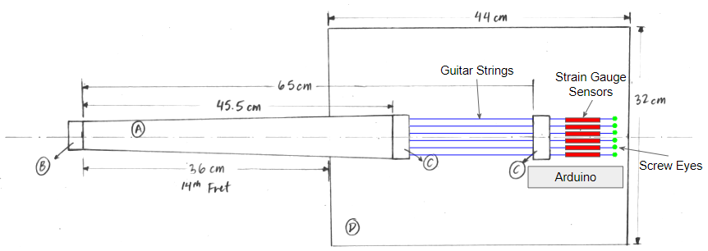
Figure 7: Securing Mechanism Location on Malek’s Guitar Drawing

Source Extracts
[1] https://sciencing.com/push-switches-work-electrical-circuit-5030234.html
[2] https://besomi.com/shop/buttons-and-switches/mini-pushbutton-switch/
[3] https://blog.se.com/access-to-energy/2018/07/13/push-buttons-and-their-widel
y-used-applications-across-industries/
[4] https://www.fierceelectronics.com/sensors/what-a-motion-sensor
[5] https://www.rfwireless-world.com/Terminology/Active-motion-sensor-vs-passi
ve-motion-sensor.html
[6] https://www.800loadcel.com/load-cells/how-a-load-cell-works.html
[7] https://www.omega.ca/en/resources/strain-gages
[8] https://www.pladiscount.com/en/prodotto/strain-gauge-pressure-sensor-for-hi
ghprecision-resistor-load-cell-electronic-scale-sensor-5kg/
[9] https://www.800loadcel.com/load-cells/how-a-load-cell-works.html
[10] https://www.senceive.com/track-infrastructure-monitoring?utm_term=strain%2
0gage&utm_campaign=Senceive_Search_US&utm_source=adwords&utm_medi
um=ppc&hsa_acc=1465457029&hsa_cam=16344764081&hsa_grp=13979625397
1&hsa_ad=585870905275&hsa_src=g&hsa_tgt=kwd-10050561&hsa_kw=strain
%20gage&hsa_mt=p&hsa_net=adwords&hsa_ver=3&gclid=EAIaIQobChMIidTK
zNKA9wIVRCc4Ch1c2gVSEAAYAiAAEgIve_D_BwE
[11] https://community.smartthings.com/t/how-to-determine-force-required-to-push
-a-door-or-button-or-lever/161757
[12] https://www.directindustry.com/prod/honeywell-advanced-sensing-technologi
es/product-12365-118650.html
[13] https://www.sparkfun.com/products/14729
[14] https://www.sparkfun.com/products/14110
[15] https://www.sparkfun.com/products/15326
[16] https://www.sparkfun.com/products/19484
[17] https://www.directindustry.com/prod/honeywell-advanced-sensing-technologi
es/product-12365-118650.html
[18] https://www.sparkfun.com/products/14729
[19] https://create.arduino.cc/projecthub/electropeak/digital-force-gauge-weight-sc
ale-w-loadcell-arduino-7a7fd5

